Steps for Create a repository in GitHub.

* GitHub repositories store a variety of projects. In this guide, you'll create a repository and commit your first change
* In the upper-right corner of any page, select +, then click New repository.

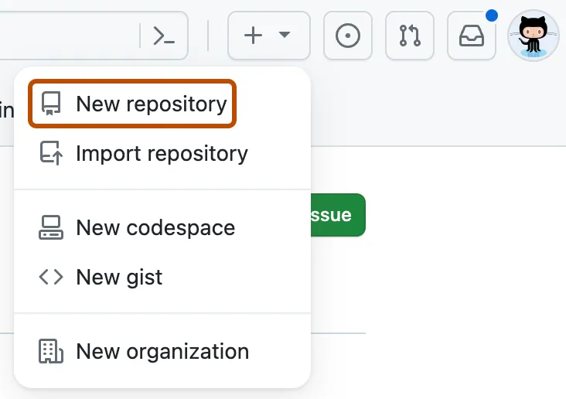

* Type a short, memorable name for your repository. For example, "hello-world".

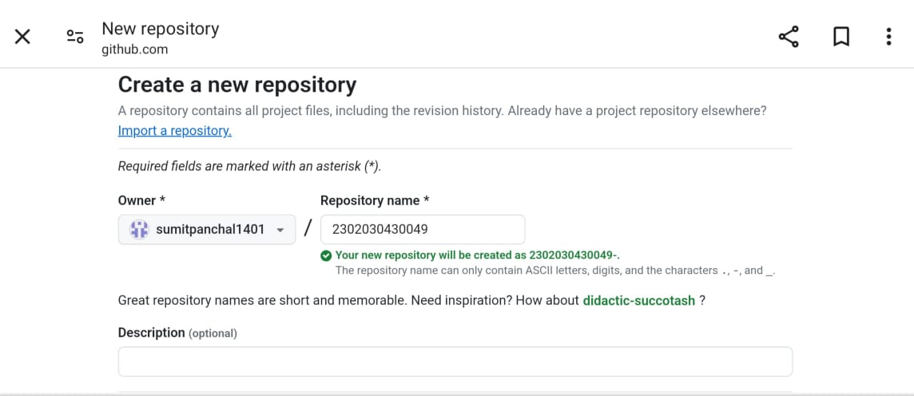

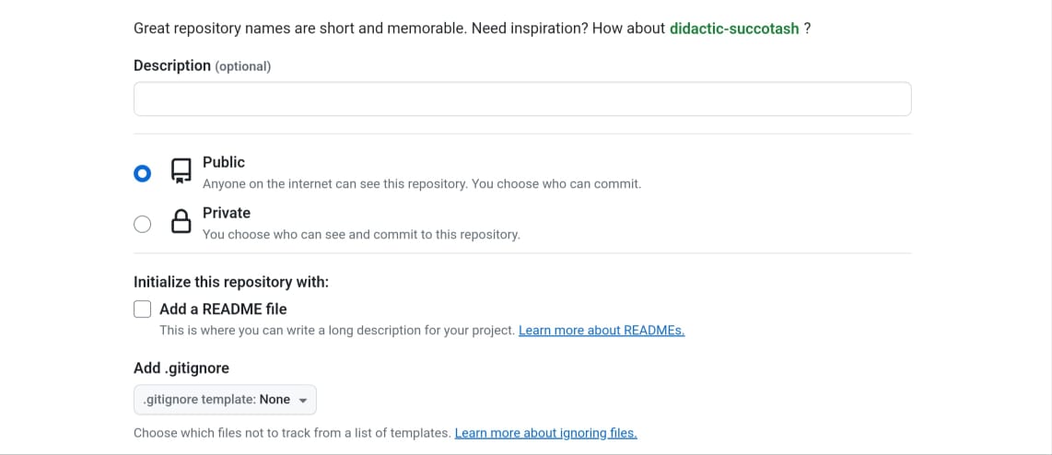

* Optionally, add a description of your repository. For example, "My first repository on GitHub."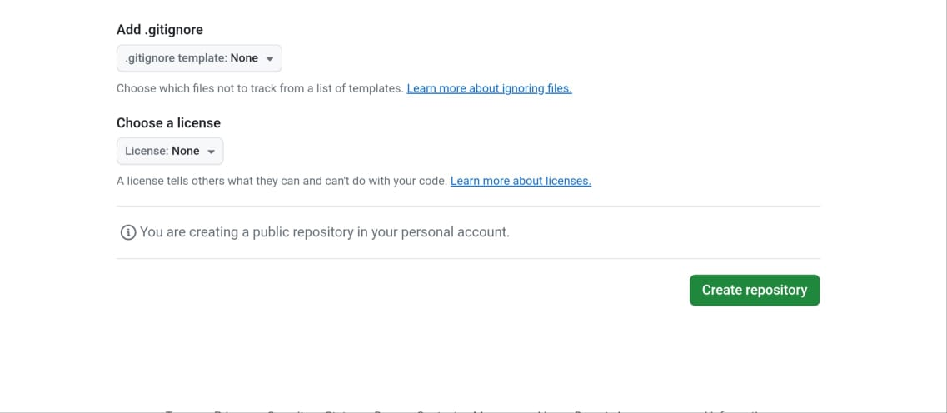
* Select Initialize this repository with a README.
* Click Create repository.
* After clicking the button, we will be directed to below page. Right now the only file we have is a readme file.

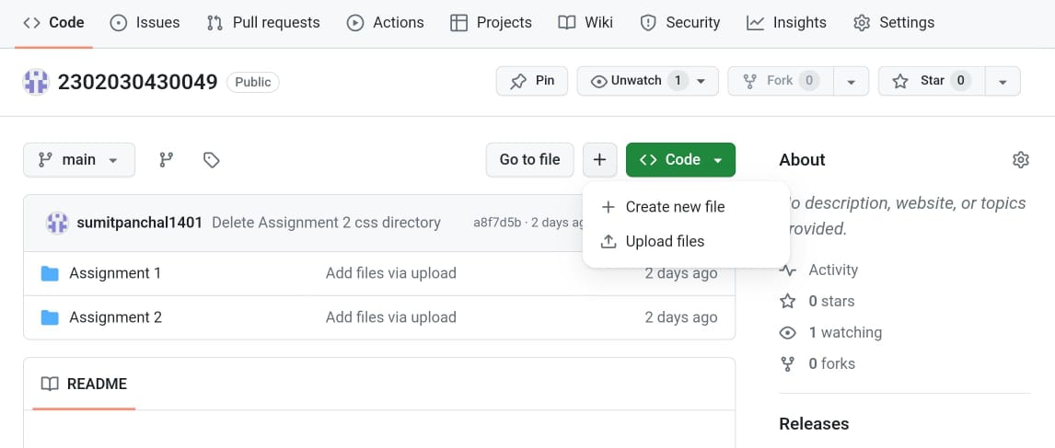

* Follow the steps mentioned in the Picture below and click “commit changes”

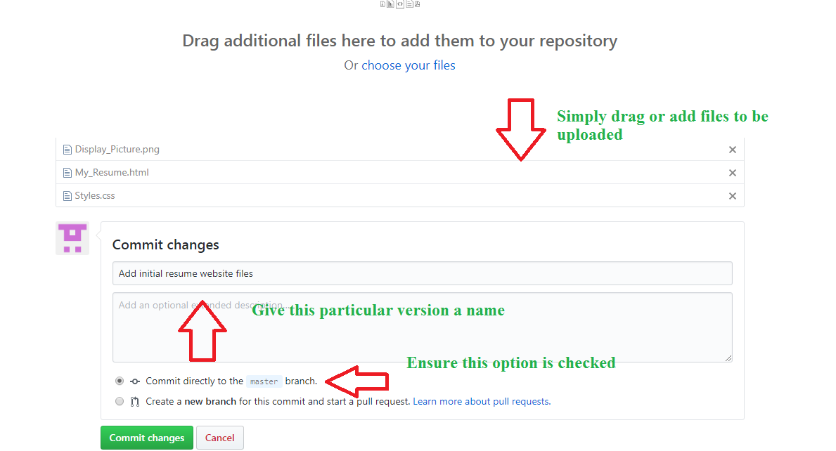

* Now you will see that all of our files uploaded in our github

